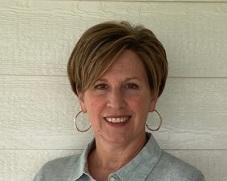
Guest Writer-Jennifer Paxton shares her experiences in developing a district-wide intensive teaching verbal behavior program with colleagues at Auburn Washburn. Jennifer was formerly the District-Wide Special Education Low Incidence Facilitator for Auburn Washburn and currently works as a state trainer on the TASN-ATBS team.
Building Capacity through Collaboration

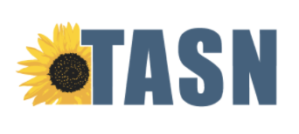
“Do this.”, “What is it?”, “Point to the ____.”, “A person who works in a library is called a ____?”. These are just some of the phrases one could hear when working in any of USD #437 Auburn Washburn’s Special Education Autism Classroom programs PreK – Transition. These teachers, along with paraprofessionals, Occupational Therapists, Speech Language Pathologists, and an Adaptive PE teacher, have all been trained in intensive teaching using Verbal Behavior and Basic Skills programs. Building a district wide, intensive teaching program the past two and a half years has been an adventure in teamwork and training as team members put together an organizational system of materials.
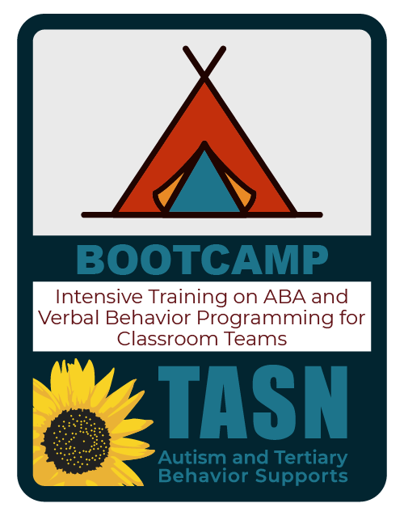
Three years ago, a small team of Auburn Washburn educators attended BOOT CAMP: Intensive Training on ABA and Verbal Behavior Programming for Classroom Teams. During the hands-on Boot Camp training participants learned how to implement the errorless teaching program using the verbal behavior operants. Team members were also trained to use the corresponding data system and taught how to use the data to make programming changes. “I remember before we left on the third day, the training participants were given options of different levels of support from our assigned TASN ATBS coaches. Our group chose the highest level of support available to us from our TASN coach Peggy VonFeldt. We knew we wanted to implement this program with fidelity.” (Jennifer Paxton, Low Incidence Facilitator.) Peggy visited the classroom in Topeka for on-site coaching and the team also spent time with her via phone calls or texting when they had questions and needed guidance.
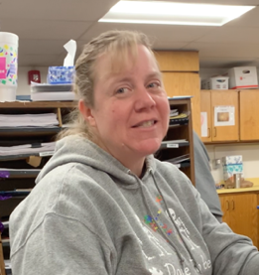
Our team returned to school and began the program with two students in Michelle South’s Special Education Autism Classroom at Auburn Elementary. A lot of collaboration took place between the South team, Speech Language Pathologist Rachel Grieves, and I to begin implementing the program with the students. The team started by assessing the students using the Verbal Behavior Milestones Assessment and Placement Program, also known as the VB-MAPP. Once the assessment was complete, we were able to use the results and develop the students’ intensive teaching programs. The program worked so well with two students that the team went on to assess all ten of South’s students. Programs were designed for the students and intensive teaching began. The team also included Kristi Teal, Occupational Therapist, and Colter Scott, Adaptive Physical Education teacher. Teal and Scott were able to design intensive teaching protocols to use in their practices with the students.
Michele South, Elementary Special Education Autism Teacher Teacher

Putting all of this into place did not happen immediately. It took time to assess students, design programs, and get materials ready. The team was able to use the district’s early release times to meet. They also used their plan times and met after school, working to develop the programs.
Paraprofessionals were trained by us before or after school and training also took place in the natural environment on the job. “We learned so much from our mistakes when we first started, but even then, I knew it was a great program because we were beginning to see small data increases in the kids. These students were at all different learning levels, from a basic skills level to learning to read and write using errorless teaching. I also have some students using AAC devices who are doing the program. Verbal Behavior is the evidenced-based program for the students in my classroom. The beauty of it is, it’s errorless, and those errors are corrected immediately with an error correction procedure. We also have a way of checking to see if the student retains the skill by giving the students opportunities to practice learned skills.” said South.
As the paraprofessionals in South’s class were trained and supported in the instructional strategies and components of the program, they also started to see the benefits. Several indicated they loved the structure and how amazing it was to see the student’s skills increase. The strategies they were gaining obviously improved the student’s outcomes but also supported their own confidence in teaching students with significant needs.
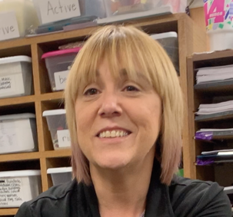
They felt proud and confident in the skills they were learning and felt valuable in the student’s learning process. Dawn, a paraprofessional in South’s classroom, who also has been trained in Social Work, shared “I couldn’t be prouder of what I am doing since we added this programming to our classroom. We can actually see on a day- to-day basis the progress our kids are making and actually chart it. For me, being able to see the data and the mastered piles get thicker helps me know that I am teaching them and helping them grow. I am very proud of the work we do, and it is exciting.”

Dawn Garza Paraprofessional
The intensive teaching programs were working so well in the autism classroom, it became important to find a way to train all staff in the specialized programs throughout the district. We approached our Director of Student Services, Jaime Callaghan, and asked her if we could bring the Bootcamp trainer, Stacey Martin, to Topeka to train our staff and have our own Boot Camp training so everyone could hear the information, learn, and practice together. Callaghan knew positive results were beginning to happen in South’s program and she wanted to make the training come to fruition. “In looking at our capacity to implement verbal behavior programs, we had something that teachers and support staff were excited about, it was evidence- based, and we had a target population identified. Having Stacey Martin come to us in Topeka to train our staff was more cost-effective and efficient. Our goal in using this program is to build capacity amongst our staff and achieve better outcomes for students and their families.” – Jaime Callaghan, Director of Student Services, Auburn Washburn
Because all staff working with low- incidence programs have attended boot camp and have been trained in the program, they are able to seamlessly transition students from one grade level or building to the next throughout their time in the district. In doing so this supports the receiving staff in getting to know the student’s strengths and needs and understanding the data that is being passed along. Administrators, teachers, related service providers, and support staff are able to look at the student’s data books and know exactly where the student left off as well as view previously targeted items and mastered items. This enables staff to start working with students immediately.
To help maintain the fidelity of the program and ensure staff got the materials they needed to teach the intensive programs, all supplies and inventory were monitored at the district level.
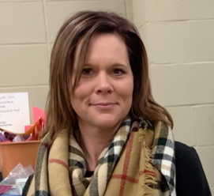
Sheila Coons, Autism Instructional Support Staff, created a check- out inventory to assign items to students. The supplies available to students are: Language Builder Cards, plastic boxes used for reinforcement items, three-drawer storage containers, plastic photo boxes used to house the current targets, colored 3x5” index cards, red/green sticker dots, and plastic shoebox size containers used to store what is called the ‘maintenance’ items, or ‘easies’. All supplies and data notebooks move with the student as they change grade levels and/or teachers throughout their time at Auburn Washburn. Coons also edits the data sheets to match the school year calendar and delivers requested items to teachers. To help offset the cost of the items purchased by the district, Coons wrote and received a two-thousand-dollar grant from the Auburn Washburn Foundation.
Sheila Coons-Autism Instructional Support Staff

There is much to consider when putting a full program together for students with complex needs. Our classrooms in Auburn Washburn implement the principles of Structured Teaching as the framework to support verbal behavior as well as other evidence-based practices. Structured teaching components include the physical setup of the classrooms, the use of visual supports, routines, work systems, and schedules. Also embedded throughout the day is social skills instruction and the implementation of communication strategies such as Picture Exchange Communication Systems, AAC devices and Sign Language. This framework, also used in the inclusive setting, is implemented so evidence-based practices can be used throughout the student’s environments and school day.
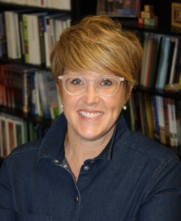
“It’s important for our staff to become generalists and be trained in many areas of evidence-based practices. This is ever evolving, and I am proud of the work everyone is doing. In doing so I feel we are able to support students across all grade levels from preschool through transition in order to achieve better outcomes for students.” Jaime Callaghan, Director of Student Services, Auburn Washburn.

Thank you to all of the Auburn Washburn Pre-School-Transition Staff and Administration for your dedication and leadership in building capacity using Verbal Behavior and Evidence Based Practices.” ~Jennifer

