Preparing the Classroom Environment

Sanitizing the Environment:

The physical environment plays a large role in motivating the student to interact and communicate with others. Free access to reinforcers is detrimental to the development and expansion of communication and interaction with others, especially for children with autism. To increase motivation, social opportunities, and communicative opportunities valuable items are placed out of reach. Pairing and manding are stressed to teach the value of communication and of the people within the environment. Pairing and manding cannot successfully occur when free access to reinforcers is given.

Therefore, teachers can arrange the classroom so that highly valued items can only be reached through communication with the staff. Ways to sanitize the environment include:

- putting items on high shelves where they can be viewed by not reached
- storing preferred items in clear bins that can only be opened by staff
- Placing edibles in clear baggies or chambered containers. (see Reinforcer Containers for more info)
- Placing reinforcers in pocket aprons or fanny packs worn by staff for instant presentation of reinforcers
- Exposing highly preferred items in rotation to keep their value strong
- Providing peers with the student’s valuable items in containers to promoting pairing and manding with peers
- Providing only parts of items to promote manding for information

Typically developing peers may benefit from exploring the environment. Children that have poor communication skills, especially children with autism, may prefer isolation from others. Free access to the environment works against developing communication skills and reduces the motivation to be with others. Sanitizing the environment becomes critical in helping to develop these skills.

Classroom Arrangement:
It is critical for the classroom environment to be arranged in a manner that will allow optimal instruction. The following considerations should be taken into account when arranging your classroom:

- Structure the classroom so that you have enough stations to allow for individual instruction as well as group instruction.

- Keep your classroom free of clutter as to allow for appropriate classroom flow (students should be able to easily navigate the environment). Special considerations should be made for students with limited mobility (wheel chairs, walkers, etc)
- Provide seating that allows for appropriate attending posture:
- Feet flat on floor
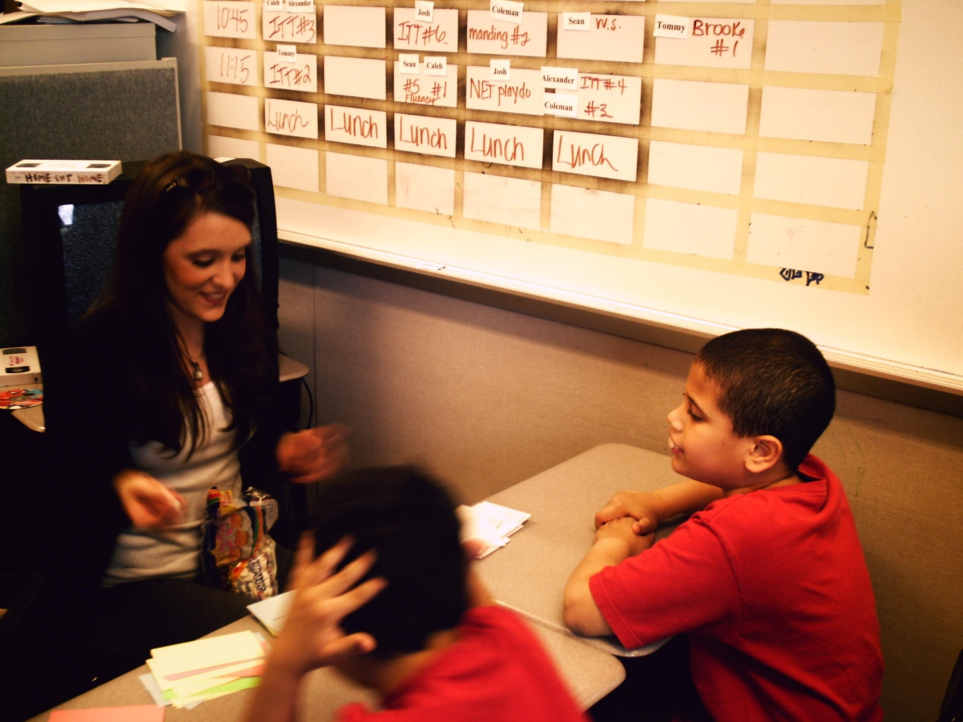
- If students are to be at a table, their chest should clear the table as to allow for proper view and manipulation of materials.
- When possible, consider desks with no storage space so students are not distracted or turn the desks so that the storage space is facing the instructor and not the student.
- Ideally, students should be seated across from instructors so keep in mind that desks need to be narrow enough to allow teacher to prompt the student if needed .
- Roll carts with materials as well s reinforcers should be easily accessible to instructor and away from students.

- When using media (TV, Computer), the ideal is to set up the area so that the instructor has control of these items as well. Note in the picture above how the TV is behind the teacher. This also helps keep students in attending position (looking toward teacher) even when reinforcement is delivered.

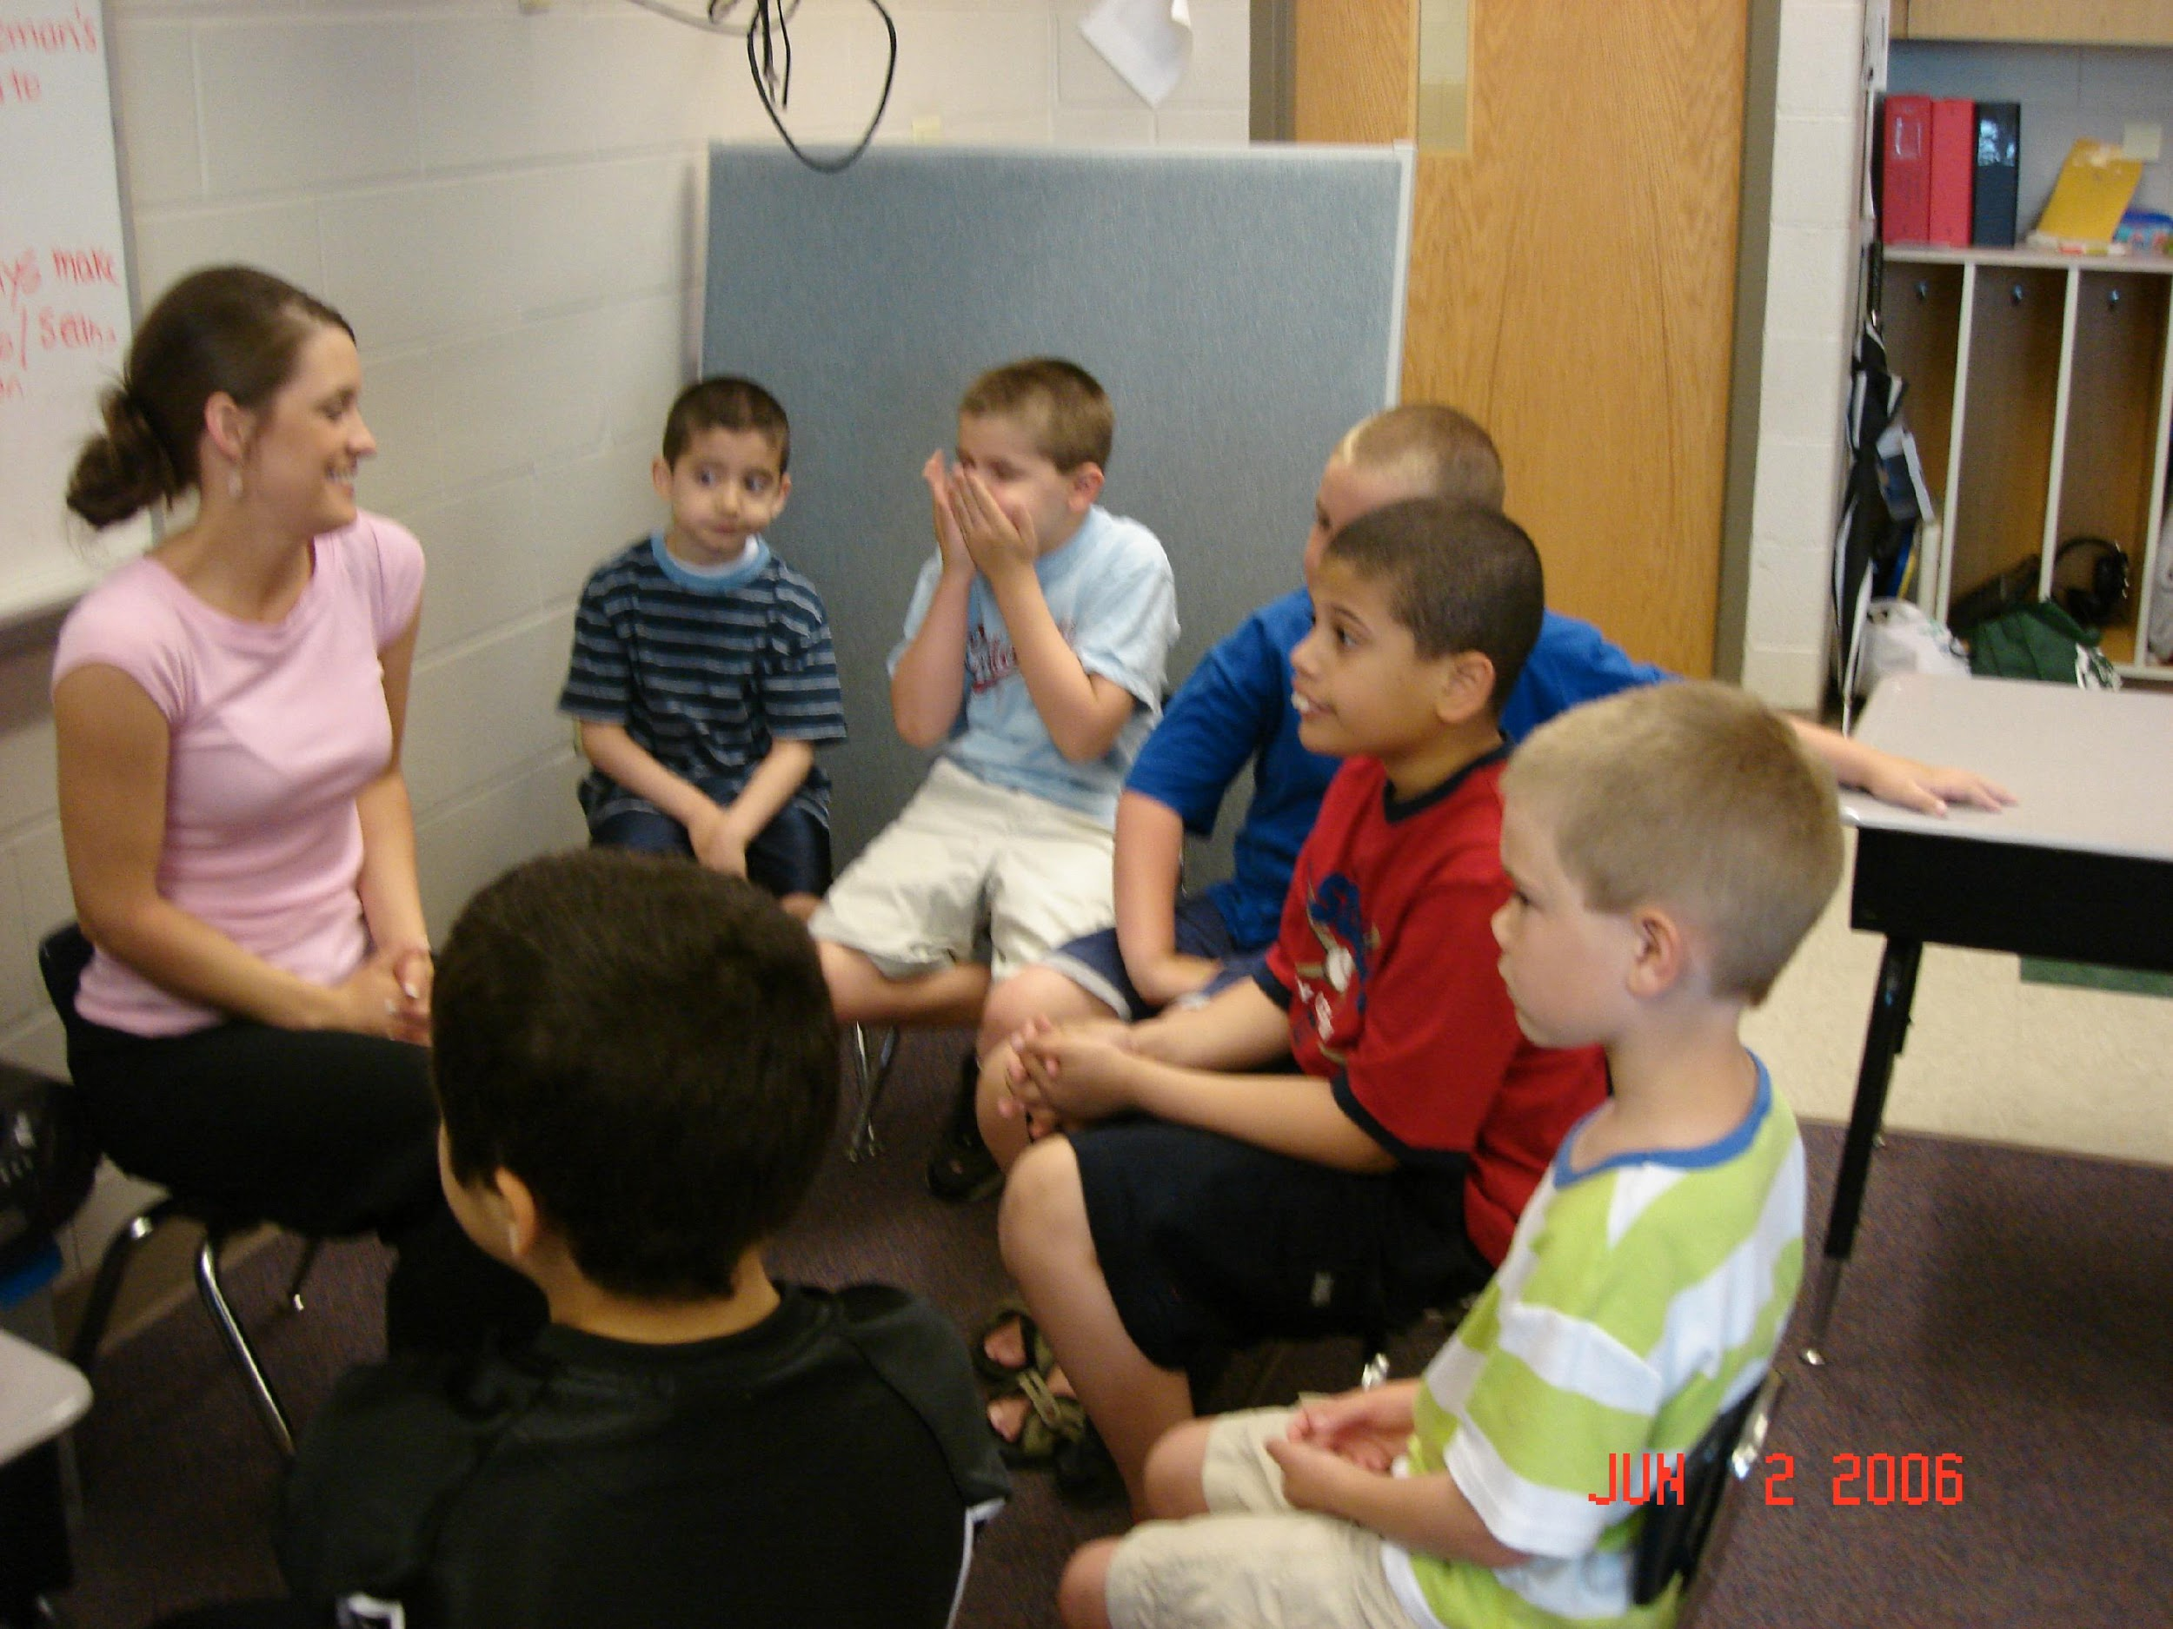
- Conduct your group sessions with students arranged in a “U” shape in front of the instructor and place the students who need the greatest amount of direct attention (prompting, redirecting) front and center.

Students should be facing the least distractible area possible (example: wall).

Avoid using tables unless they are necessary for student materials.

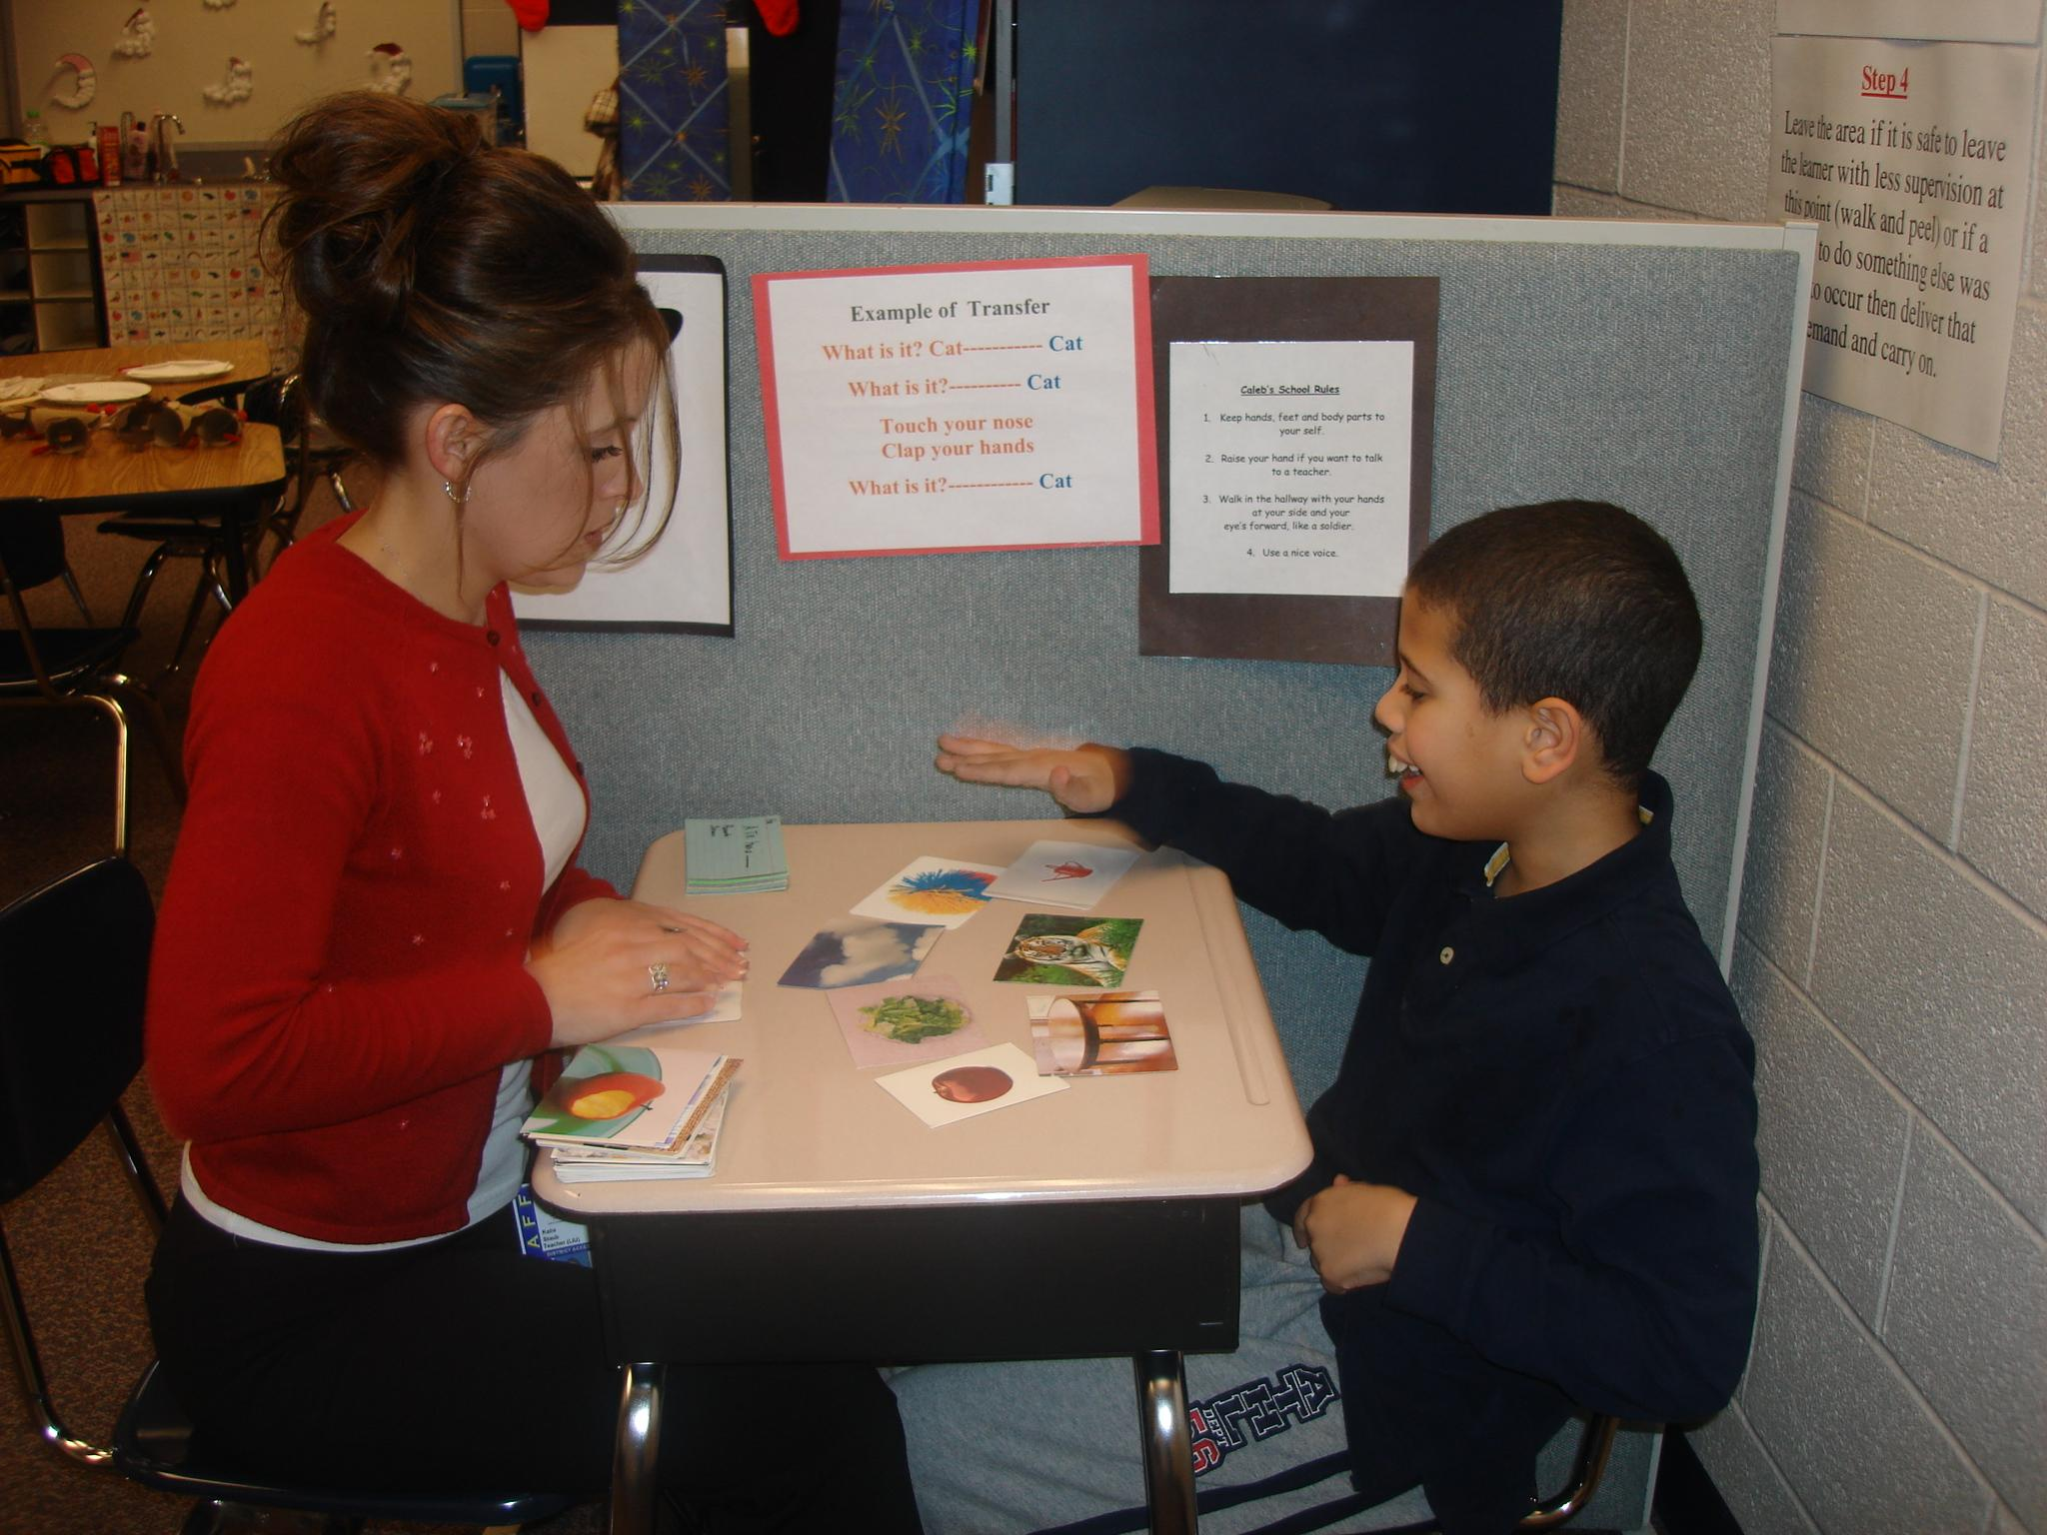
- If partitions/dividers are needed to structure your classroom and/or minimize distraction for students during individual instruction, consider short dividers that will accomplish the purpose but at the same time allow the teacher to have a clear view of the entire classroom at all times.

- If you need to position students to minimize likelihood of eloping, consider the surrounding area (wall behind student, student has to go pass you to leave the area). However, do not prohibit liberty of motion or entrap the student
.

Posters

Your consultant will provide you with many ABA/VB posters. These are teaching and prompting aids for you and your staff. They provide at-a-glance information to help you be as efficient and effective as possible throughout your day. They also reflect your dedication as a team to the children you serve. Read and refer to the information often. It is not a room beautification but instead room edification!! Though we do try to make posters look nice…

Also consider posting reminders to help staff implement behavior intervention plans or other specific programming considerations with fidelity. Some suggested items to post are:

- Student VR’s
- Student Reinforcers
- Targets to address for NET
- BIP procedures
- Behaviors targeted for reduction
- Description and or pictures of student signs
- Prompt levels and/or prompt fading procedures
- Target mands

Clipboards

Each student will have a clipboard that is controlled by staff. The clipboard will contain all data collection documents for that particular student. Data on the clipboards is collected and monitored daily and the attached sheets are organized in the student’s program book when appropriate. Data sheets are updated/refreshed daily or weekly. The classroom teacher monitors, guides, and manages this “paperwork”. Many staff may be involved in just one student’s data collection. Consistency in data collection procedures is critical to the reliability of the data and the teaching of the students. Monitor procedures often to avoid procedural drift. Procedural check lists allow for objective monitoring of procedures.

Some examples of data to include on clipboards:

- Weekly Probes
- Behavior data
- Echoic data
- Reinforcer lists
- Prompting level data
- The student’s schedule
- Program schedules or changes

Student Roll Carts

Each student will have their own three-drawer roll cart (make sure you properly identify each cart by placing a label with student’s name on the front). The purpose of the roll cart is to keep each student’s materials neat, organized, and mobile. The cart is wheeled out to the instruction area as needed and moved out of the way when not in use. It is not for student use, only instructor use.

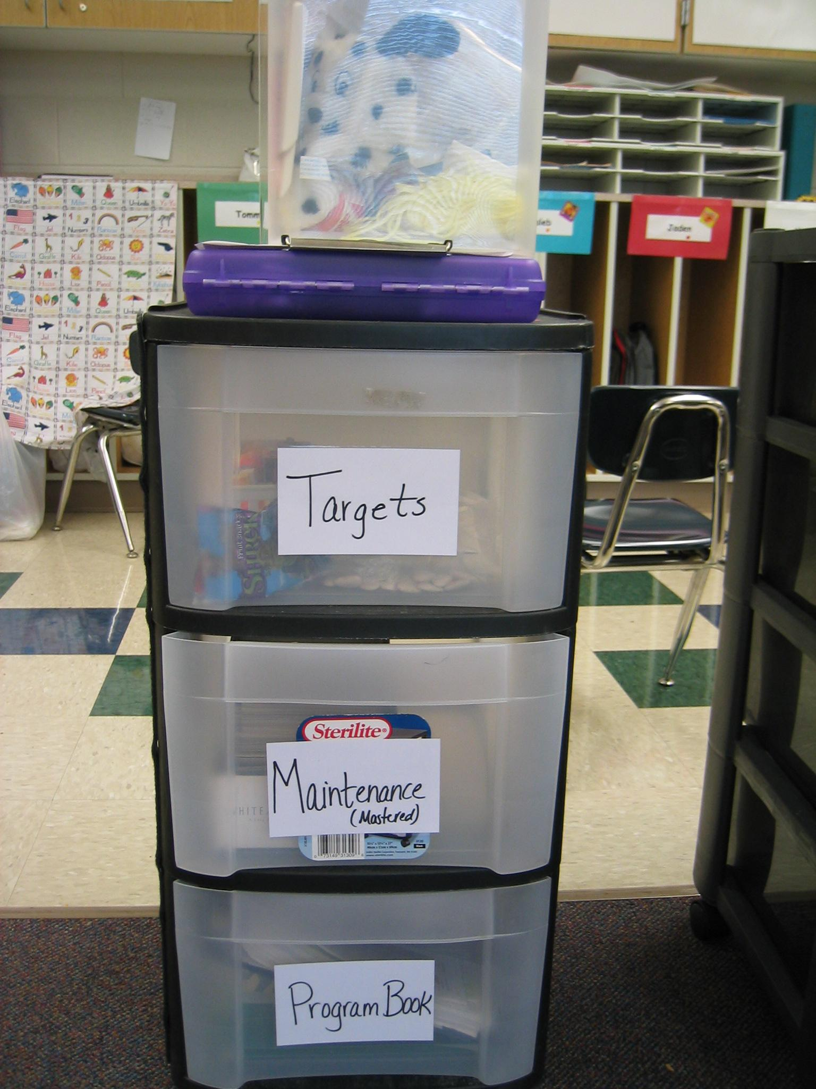

Suggested Labels for Drawers: To meet individual student and classroom needs

Program Materials: clip boards, program book, VB-MAPP protocols
Reinforcers: edibles reinforcers, tangibles reinforcers, small/med activities, DVD’s etc.
Targets: future targets, daily targets
Maintenance: card sort boxes, picture cards, known objects/match to samples
Visual Performance: Match to sample objects, puzzles, form box, blocks

Reinforcer Containers

Each morning fresh food reinforcers should be prepared and placed in the reinforcer drawer. At the end of the day, edibles should be purged and properly stored.

Make sure that all non-edible items are returned to the cart for future use. Consider rotating some items in and out to keep the value of all reinforcers strong.

If you have the issue of students accessing reinforcers from the drawers, then consider a separate container that the instructor can have better control over the reinforcers. You can see an example of this in the above picture where the reinforcers are kept in a separate container (on top of cart), that the teacher can keep beside her during instruction for better control.

Only use a partitioned reinforcer container for edibles if the student has strong mands for the items in the container. Having the reinforcers in close proximity without a strong mand repertoire will produce generalized manding or scrolling behaviors. For students with a weak mand repertoire, place food reinforcers in individual baggies and space baggies apart from one another. Now if the student points, touches, or provides eye gaze you will be able to verify motivation before you prompt a mand for the correct item and not be guessing about which item the student wants. Keep this in mind with non-edible items as well, though they will not need to be placed in baggies.

Sample Containers/items that can be used for controlling reinforcers:

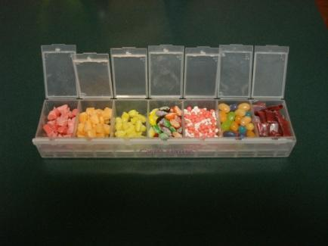
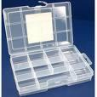
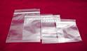
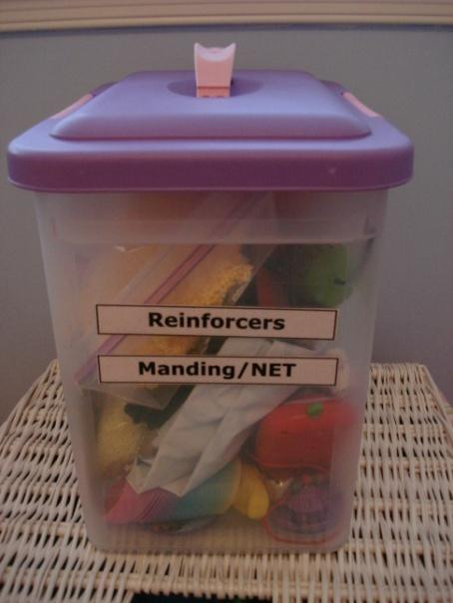
PATTAN Autism Initiative Resource File
http://webapps.pattan.net/files/PaTTANAutismResources.zip

