School Pet Caregiver

(adapted from “Meaningful Jobs” – Scott May, Principal, Apollo Elementary, Goddard, Kansas)
The Kansas vision for education includes postsecondary and career preparation, social engagement, and communication as the foundational structures of education in our schools and classrooms. From simple jobs in the earliest grades through high school internships, meaningful work supports the academic and social competencies that lead to post-school success.
“Meaningful jobs allow students the opportunity to contribute in a way that both the students and the adults see value. Everyone likes to contribute to their family or workplace in meaningful ways. These responsibilities give students with disabilities or behavior concerns the opportunities to have repeated positive interactions with others and learn from those experiences." - Scott May

The ideas and supports included in these resources are ready to be edited to support growth and independence for individual students.

Job Description
The School Pet Caregiver provides water and food to the school therapy dog and takes him on a morning walk before school starts.
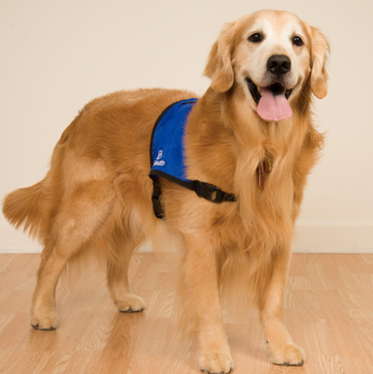
www.reidhealth.org
Job Duties
Report to your supervisor
Put food and water in Sammy’s bowls
Take Sammy on a walk
Return to class

Sample visual supports
Below are checklists and visual supports that might be used to support the student in preparation for this important school job. Some students will benefit from having a checklist with pictures or photos to complete the steps of the job, while others might only need a checklist with words. As you can see, these steps can easily be modified to fit the needs of the student and to align with the requirements of the job in your school.
School Pet Caregiver
 | Step: | √
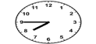 | - Report to Mrs. Tolbert at 7:45
 | - Put food in Sammy’s bowl
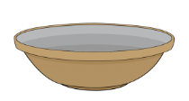 | - Put water in Sammy’s bowl
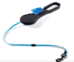 | - Put Sammy’s leash on
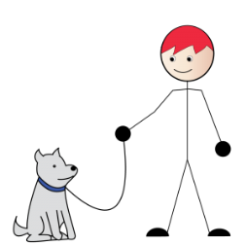 | - Walk Sammy around the gym 4 times
 | - Take Sammy’s leash off
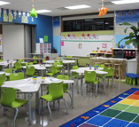 | - Go back to class

Visual Support for keeping track of laps while walking the dog:
- Print and laminate the visual support
- Cut out the stars and attach to a white strip with Velcro
- Attach the strips to the gym wall
- After every lap the student moves a star down so that he knows when he has completed four laps

Lap 2
Lap 3
Lap 4
Lap 1
More Pet Care visual supports
(materials created by and used with permission: EDULYNC LLC 2017)

(Materials created by and used with permission from 2017 EduLync LLC)
Feed the Dog
____Measure 3/4 cup food
____Pour food in bowl
____Measure 1 cup water
____Pour water in bowl

Materials can be color-coded to provide clarity to the steps of the task.
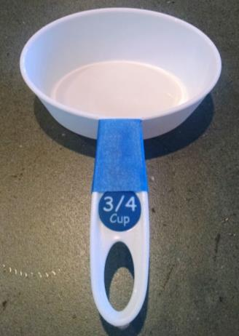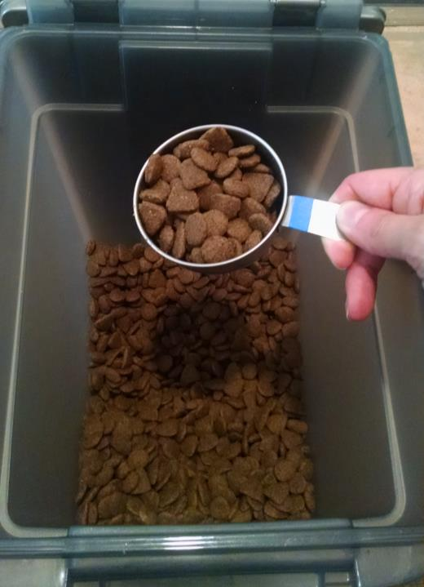

All of the visual supports shown could easily be adapted for any type of pet. These visual supports could also be used in a school-wide job, classroom job, or shared with families to be used at home. Using real photos in the student’s environment would further individualize these supports.
Feeding A Pet
____Fill food bowl with ____ of food
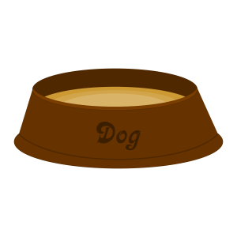
____Fill water bowl with____ of water
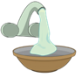

Pet Care
____Walk dog 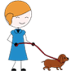

____Give a treat 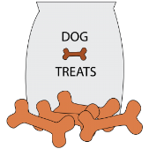
____Fill food bowl 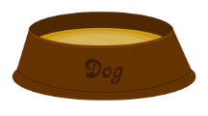

____Fill water bowl

A flip book could be created to show the steps of the task one at a time. Real photos, or the icons below, could be used.
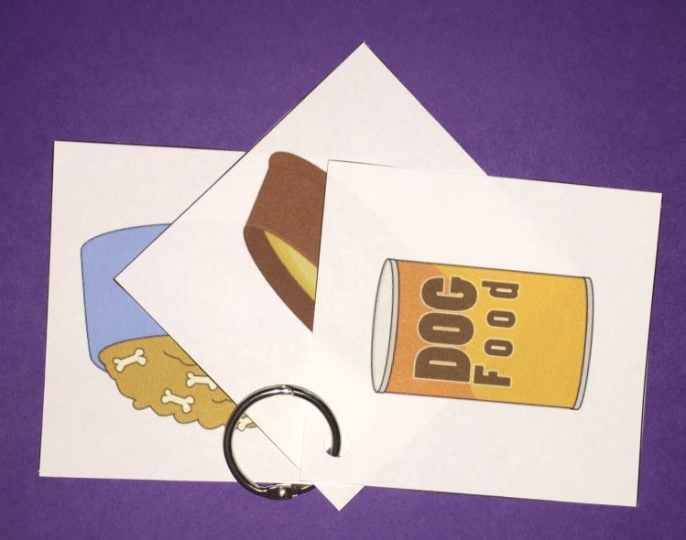
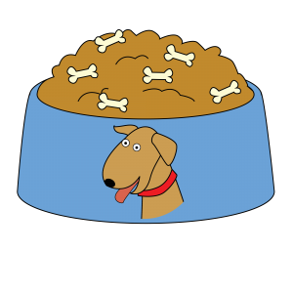 | 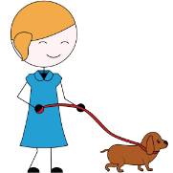

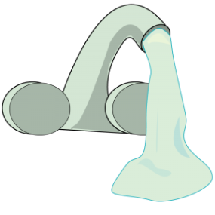 | 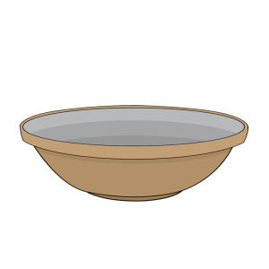 | 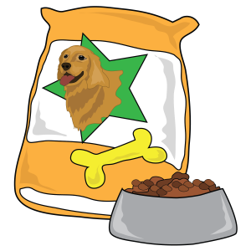
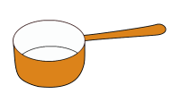 | 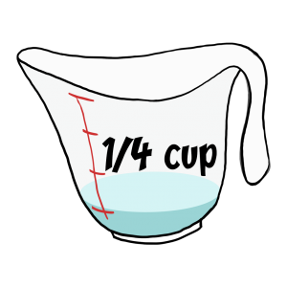 | 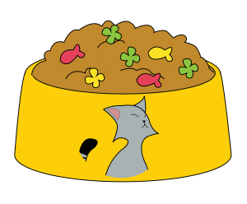
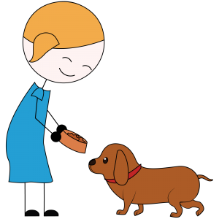 |  | 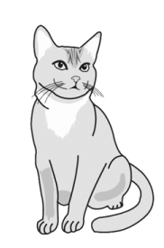

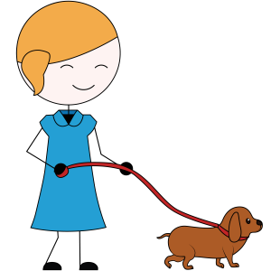 | 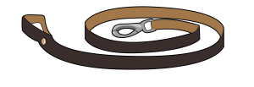 | 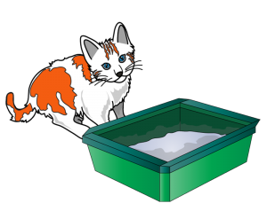
 | 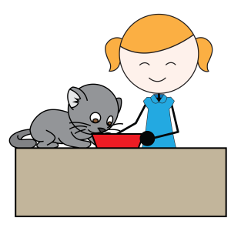
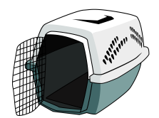 | 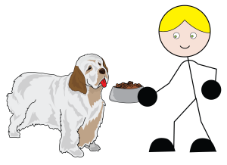 | 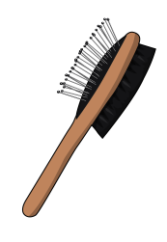
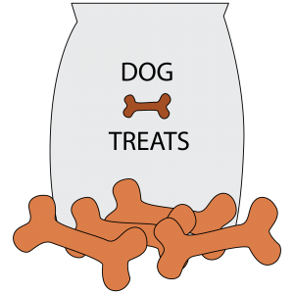

The content of this presentation was developed under an agreement from the Federal Department of Education to the Kansas Department of Education. However, those contents do not necessarily represent the policy of the Department of Education, and you should not assume endorsement by the Kansas Department of Education or the Federal Government. TASN Autism and Tertiary Behavior Supports does not discriminate on the basis of race, color, national origin, sex, disability, or age in its’ programs and activities. The following person has been designated to handle inquiries regarding the non-discrimination policies: Deputy Director, Keystone Learning Services, 500 E. Sunflower, Ozawkie, KS 66070, 785-876-2214.

