Vending Machine Manager

(adapted from “Meaningful Jobs” – Scott May, Principal, Apollo Elementary, Goddard, Kansas)
The Kansas vision for education includes postsecondary and career preparation, social engagement, and communication as the foundational structures of education in our schools and classrooms. From simple jobs in the earliest grades through high school internships, meaningful work supports the academic and social competencies that lead to post-school success.
“Meaningful jobs allow students the opportunity to contribute in a way that both the students and the adults see value. Everyone likes to contribute to their family or workplace in meaningful ways. These responsibilities give students with disabilities or behavior concerns the opportunities to have repeated positive interactions with others and learn from those experiences." - Scott May

The ideas and supports included in these resources are ready to be edited to support growth and independence for individual students.

Job Description
The vending machine manager checks and fills the vending machine.
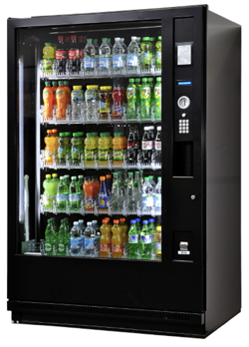

Job Duties
Report to the supervisor for your job assignment
Unlock vending machine and take inventory using the sheet provided
Fill empty spots with the products left by the delivery man
Lock the vending machine and hang up key
Return to class

Sample Visual Support
Some students would need a checklist with both words and photos while others might be able to use a checklist with just words.
Vending Machine Checklist
- Report to Mr. Ratey
- Unlock the vending machine
- Count the products
- Write down the number of each drink
- Fill the vending machine | 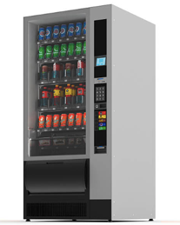
- Lock the vending machine
- Return to class

The content of this presentation was developed under an agreement from the Federal Department of Education to the Kansas Department of Education. However, those contents do not necessarily represent the policy of the Department of Education, and you should not assume endorsement by the Kansas Department of Education or the Federal Government. TASN Autism and Tertiary Behavior Supports does not discriminate on the basis of race, color, national origin, sex, disability, or age in its’ programs and activities. The following person has been designated to handle inquiries regarding the non-discrimination policies: Deputy Director, Keystone Learning Services, 500 E. Sunflower, Ozawkie, KS 66070, 785-876-2214.

