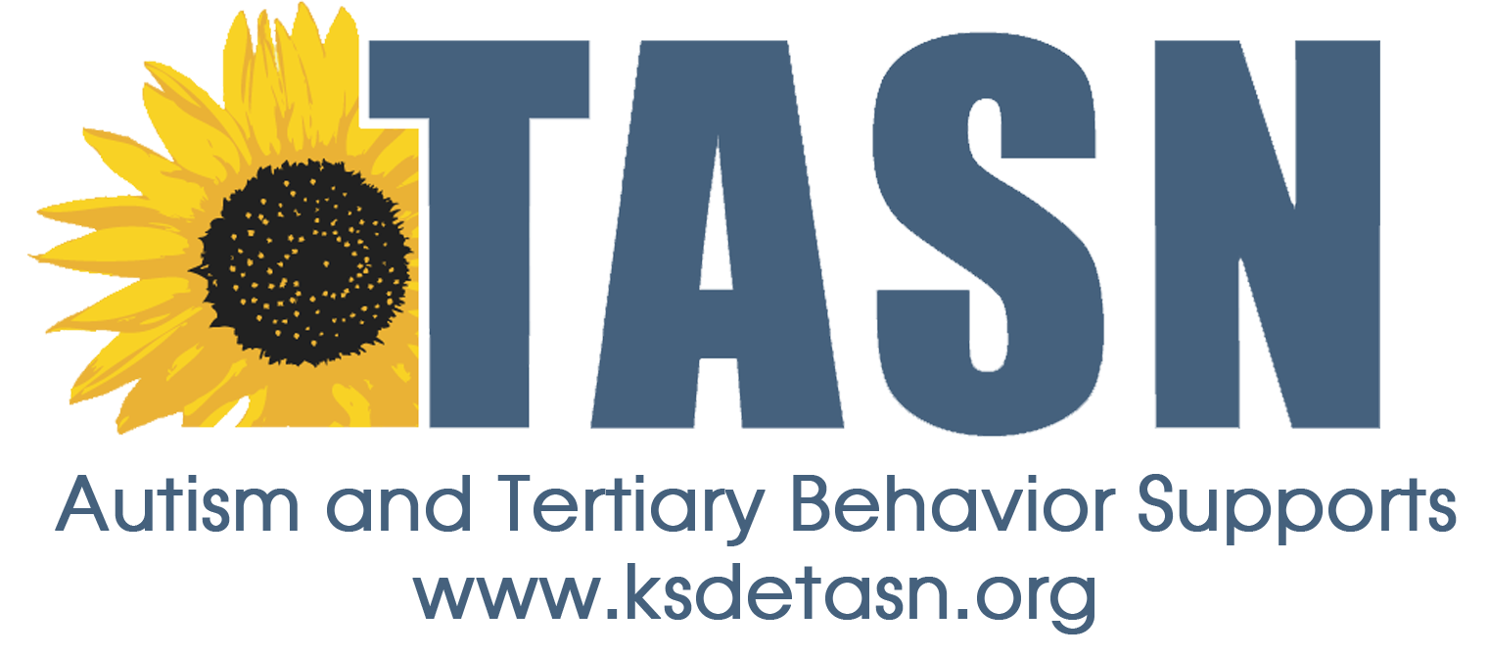
TASN ATBS SCHOOL MENTAL HEALTH INITIATIVE
WEBINAR STUDY QUESTION FORM

Webinar Title: 7 Essential Ingredients of Trauma Sensitive Schools
Presenter: Sara Daniel, MSW, LCSW
Webinar Date: March 9, 2017, 45 minutes

To earn a Certificate of Attendance complete and submit the Webinar Study Question Form to JENNIFER HOUSER (jenh@tasnatbs.org ).

1. Name:
2. Email Address:
3. School District:
4. Role (Teacher, para, SLP, etc.):

Study Questions:
- Name two things you will do differently in response to having increased awareness of the impact of trauma for students in the classroom.

- Identify one step you will take toward improving your self-care or the culture of self-care in your school.

