De-escalation Handout

Key Message: We know ______________ about effective ____________ strategies than we do about how to address challenging behavior once it occurs.

Your Student_______________________

Antecedent “trigger” | Behavior(s) | Consequence
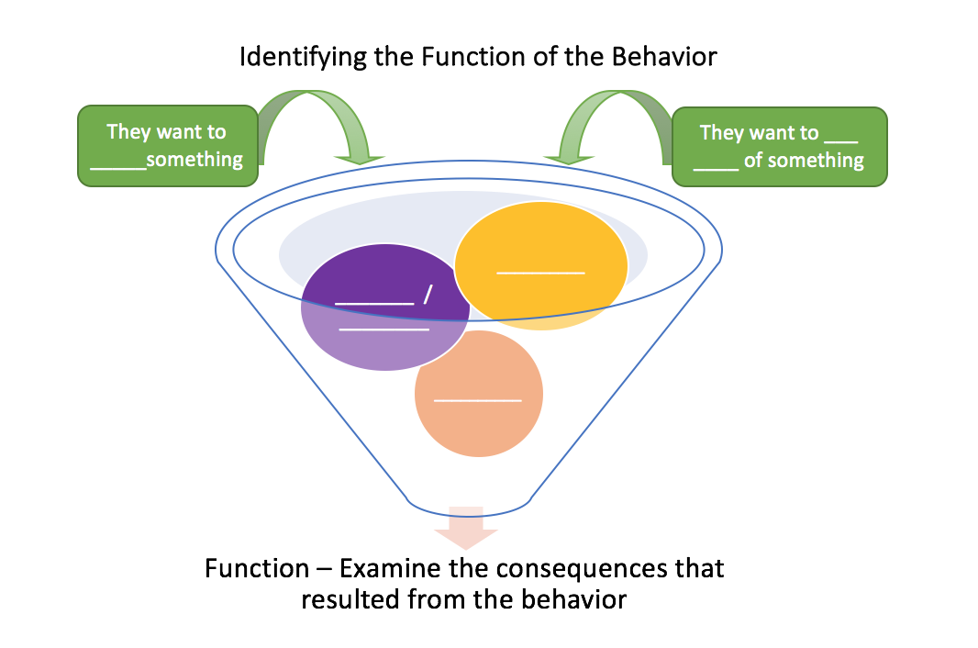

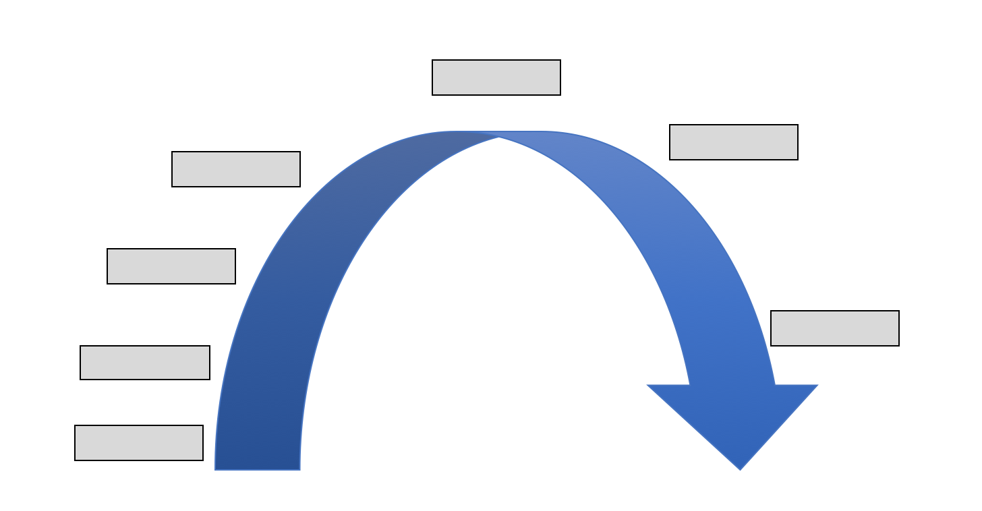

De-escalation Videos links

Module 1: Introduction, https://ksdetasn.org/resources/1033

Module 2: Signs of Escalation, https://ksdetasn.org/resources/1100

Module 3: Escalation: Early Intervention, https://ksdetasn.org/resources/1102

Module 4: Escalation Reaction, https://ksdetasn.org/resources/1104

Module 5: Crisis Management, https://ksdetasn.org/resources/1106

Module 6: Dealing with Student Non-Compliance, https://ksdetasn.org/resources/1108

Module 7: Dealing with Student Disruption, https://ksdetasn.org/resources/1110

Module 8: Dealing with Student Disrespect, https://ksdetasn.org/resources/1112

Module 9: Dealing with Provocative Student Behavior, https://ksdetasn.org/resources/1114

Module 10: Dealing with Aggressive and Fighting Behavior, https://ksdetasn.org/resources/1116

Escalation Cycle (adapted from Bounds, 2003)
Specific Student Responses
Calm  Cooperative | Triggers  Unresolved conflicts | Agitation  Unfocused | Acceleration  Focused & intense | Peak  Most severe | De-escalation  Confused | Recovery  Non-engage/alone
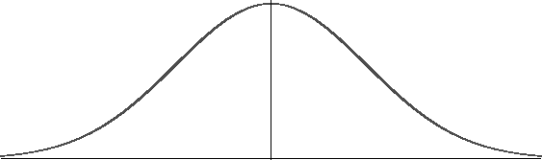

Specific Staff/Adult Response
Prevention | Prevention and redirection | Reduce anxiety | Safety | Crisis intervention | Remove excess attention | Re-establish routines

Appropriate Responses to the Seven Phases of the Escalation Cycle
Managing the Cycle of Acting-Out Behavior in the Classroom (Colvin and Scott, 2015)

Phase 1: Calm
Classroom Structure & Quality Instruction
- Supervise, reduce distractions, and provide quiet space.
- Establish and teach CLEAR expectations and acknowledge and praise compliance.
- Establish routines to decrease downtime and disruptions.
- Plan ahead for transitions and entry and exit routines.
Phase 2: Triggers
- Identify the situation where the behavior is likely to occur.
- Use pre-correction to teach appropriate response. Rehearse the expectations, prompt or remind students as needed, provide specific praise and reinforcement.
- Work with all staff and faculty to teach and reinforce social skills.
- Group social skills, anger management, community services.
Phase 3: Agitation
- Show empathy: recognize the student’s problem and communicate concern.
- Redirect and help the student become engaged in activity, lesson or task (passive or movement).
- Provide choices.
- Provide space in a quiet area or allow students to disengage briefly or put their heads down.
- Use proximity or brief interactions; show acceptance.
Phase 4: Acceleration
- Pause and Assess- “Is this an emergency situation?”
- Avoid escalating the student’s behavior.
- Pausing rather than responding immediately shows students that while they may be out of control, staff are calm and controlled.
- Use a calm but serious tone.
- If the situation escalates, withdraw and follow school procedures for emergency situations.
Phase 5: Peak
- Focus on student and staff safety.
- Notify necessary staff of situations and provide directions for response.
- If needed, evacuate others.
- Contact appropriate assistance.
Phase 6: De-escalation
- Once escalation is over, allow student space to calm down, under supervision.
- Provide independent work that is fairly easy to complete to help regain focus.
- Debrief and document the incident to provide data for ongoing planning for safety.
Phase 7: Recovery
- Help student return to normal activities and engage in learning.
- Continue with planned consequence and do not discuss or negotiate.
- Acknowledge cooperative and appropriate behavior.
- Encourage and support student in changing problem behavior.

Colvin, G. (2004). Managing the cycle of acting-out behavior in the classroom. Eugene, OR: Behavior
Associates.

